Jenkins

[**https://wiki.jenkins-ci.org/display/JENKINS/Installing+Jenkins+on+Red+Hat+distributions**](https://wiki.jenkins-ci.org/display/JENKINS/Installing+Jenkins+on+Red+Hat+distributions)

**This link will give you the instruction on how to download jenkins into the yum repository and install it. Jenkins also need Java to work. It has information of how to install java and how to restart jenkins.**

**By default jenkins will listen to port 8080. Once it is installed, call it through any web browser like below:**

**http://<your linux Server IP>:8080**

**you can also restart jenkins from browser like below:  
  
http://<your linux Server IP>:8080/restart**

A web application is defined as a hierarchy of directories and files in a standard layout. Such a hierarchy can be accessed in its "unpacked" form, where each directory and file exists in the filesystem separately, or in a "packed" form known as a **Web ARchive**, or **WAR** file.

**How to Start Stop Apache Tomcat via Command Line? Check if Tomcat is already running and Kill command**

[Apache Tomcat](http://crunchify.com/category/apache-tomcat/) (or simply Tomcat) is an open source [web server](http://crunchify.com/what-is-cross-origin-resource-sharing-cors-how-to-add-it-to-your-java-jersey-web-server/) and servlet container developed by the Apache Software Foundation (ASF). Tomcat implements the [Java Servlet](http://crunchify.com/how-to-resolve-exception-httpservlet-cannot-be-resolved-to-a-type/) and the JavaServer Pages (JSP) specifications from Oracle Corporation, and provides a “pure Java” HTTP web server environment for [Java](http://crunchify.com/category/java-web-development-tutorial/) code to run.

If you have any of below questions then you are at right place:

* Several ports (8080, 8081, 8082) required by Tomcat Server at localhost are already in use
* Tomcat Server Error – Port 8080 already in use
* port 8080 required is in use
* port 8080 already in use eclipse
* how to stop port 8080 in windows

Mac/Linux/Unix (if you have downloaded binaries as .zip)

* To Start server: <Tomcat Root>/bin>./catalina.sh start
* To Stop server: <Tomcat Root>/bin>./catalina.sh stop

Below are all catalina.sh command parameters:

catalina.sh

|  |  |
| --- | --- |
| 1  2  3  4  5  6  7  8  9  10  11  12  13  14  15 | Usage: catalina.sh ( commands ... )  commands:    debug             Start Catalina in a debugger    debug -security   Debug Catalina with a security manager    jpda start        Start Catalina under JPDA debugger    run               Start Catalina in the current window    run -security     Start in the current window with security manager    start             Start Catalina in a separate window    start -security   Start in a separate window with security manager    stop              Stop Catalina, waiting up to 5 seconds for the process to end    stop n            Stop Catalina, waiting up to n seconds for the process to end    stop -force       Stop Catalina, wait up to 5 seconds and then use kill -KILL if still running    stop n -force     Stop Catalina, wait up to n seconds and then use kill -KILL if still running    configtest        Run a basic syntax check on server.xml - check exit code for result    version           What version of tomcat are you running? |

Startup Screenshot:

[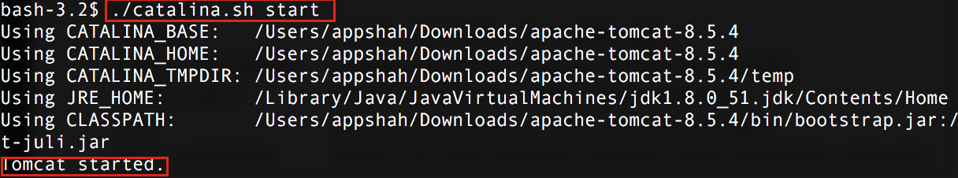](http://cdn.crunchify.com/wp-content/uploads/2012/11/Tomcat-Server-started-Crunchify-Tips.png)

**How to check if Tomcat is already running and kill existing tomcat process**

#### Step-1. Find out the process using command ps -ef | grep tomcat

|  |  |
| --- | --- |
| 1  2  3 | bash-3.2$ ps -ef | grep tomcat    502 56188     1   0  7:31PM ttys001    0:04.23 /Library/Java/JavaVirtualMachines/jdk1.8.0_51.jdk/Contents/Home/bin/java -Djava.util.logging.config.file=/Users/appshah/Downloads/apache-tomcat-8.5.4/conf/logging.properties -Djava.util.logging.manager=org.apache.juli.ClassLoaderLogManager -Djdk.tls.ephemeralDHKeySize=2048 -classpath /Users/appshah/Downloads/apache-tomcat-8.5.4/bin/bootstrap.jar:/Users/appshah/Downloads/apache-tomcat-8.5.4/bin/tomcat-juli.jar -Dcatalina.base=/Users/appshah/Downloads/apache-tomcat-8.5.4 -Dcatalina.home=/Users/appshah/Downloads/apache-tomcat-8.5.4 -Djava.io.tmpdir=/Users/appshah/Downloads/apache-tomcat-8.5.4/temp org.apache.catalina.startup.Bootstrap start    502 56618 55587   0  7:34PM ttys001    0:00.00 grep tomcat |

Here 2nd column value is a process ID. In our case it’s 56188.

You could visit link http://localhost:8080 and you should see welcome page.

[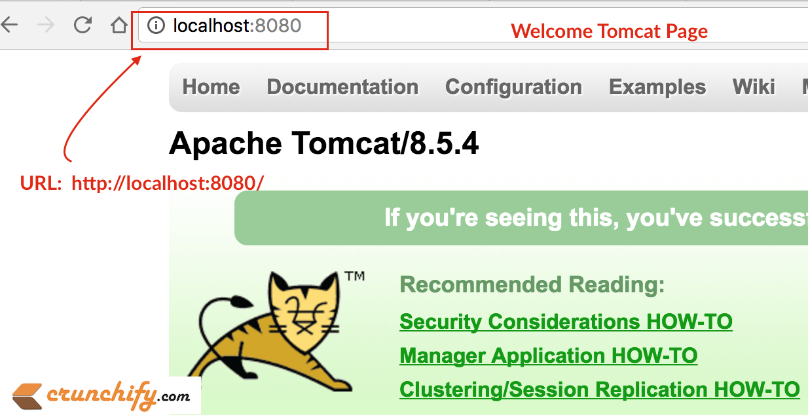](http://cdn.crunchify.com/wp-content/uploads/2012/11/Welcome-Tomcat-Page-Crunchify.png)

#### Step-2. Kill process using command kill -9 <process ID>

kill tomcat process

|  |  |
| --- | --- |
| 1 | bash-3.2$ kill -9 56188 |

Here, 56188 is a process ID which we got it from step-1.

Now, link http://localhost:8080/ shouldn’t be working for you.

Apache is an HTTP Server, serving HTTP. Tomcat is a Servlet and JSP Server serving Java technologies.